OUTPUT:
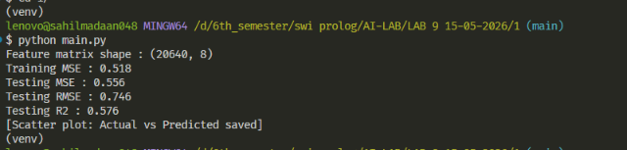

PLOT:
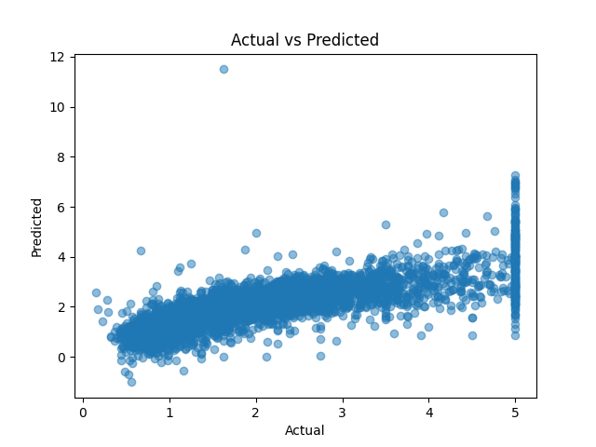

Lab 9
Program 1 —Linear Regression on California Housing Dataset
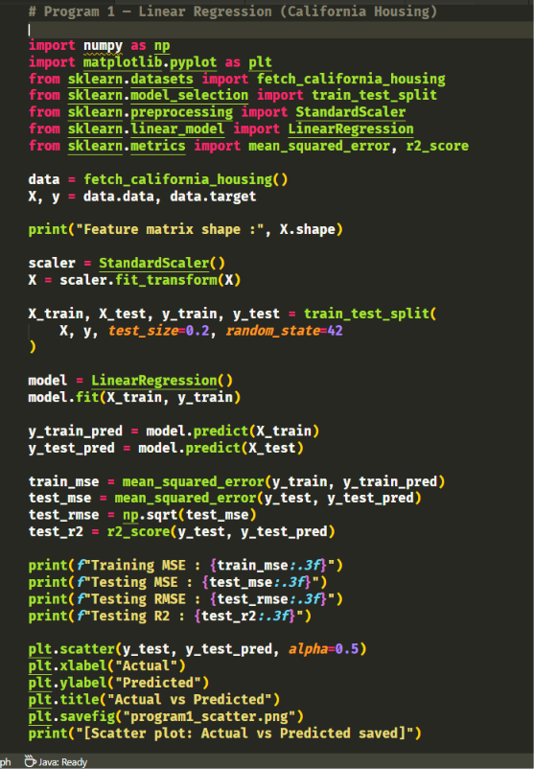
-

OUTPUT:
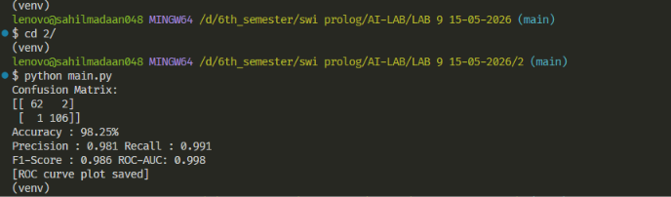

PLOT:
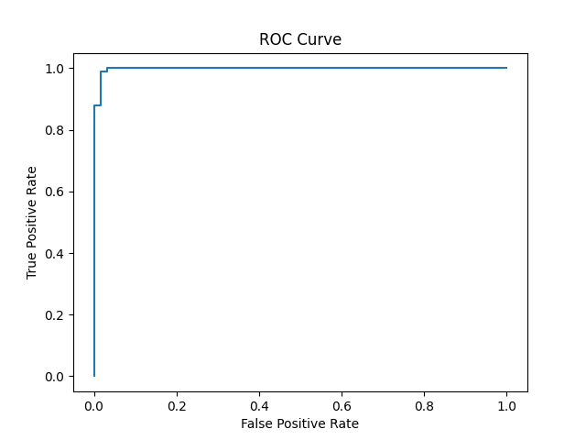

Lab 9
Program 2 —Logistic Regression for Binary Classification

-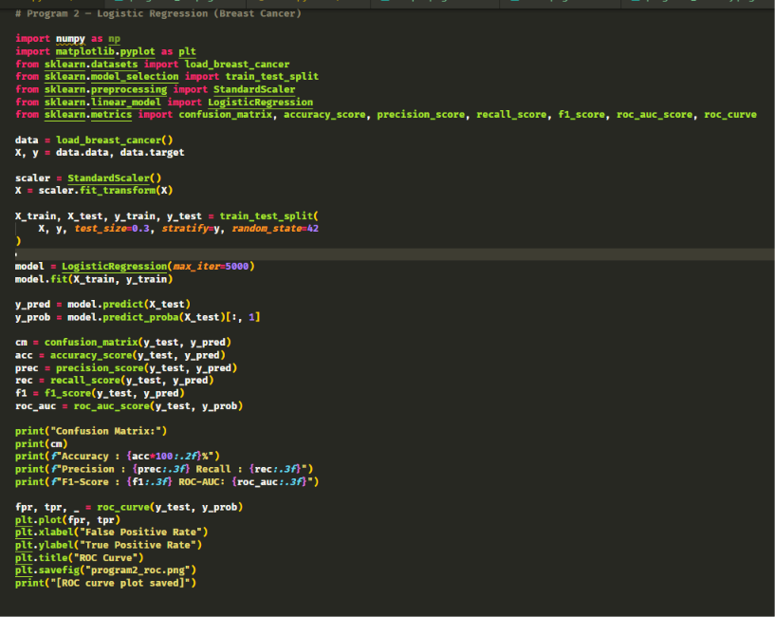

OUTPUT:
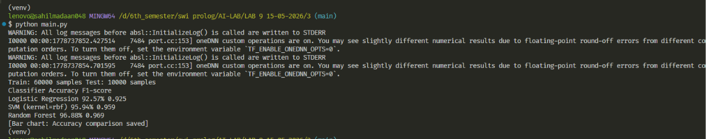

PLOT::
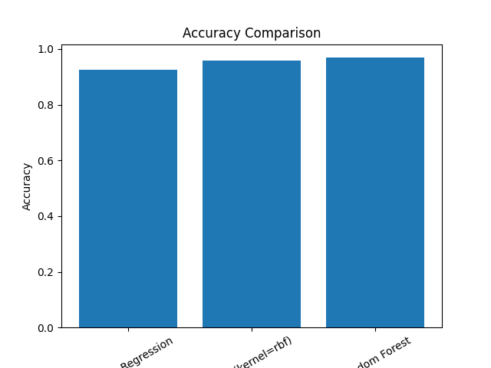
Lab 9
Program 3 — MNIST Digit Classification using Multiple Classifiers
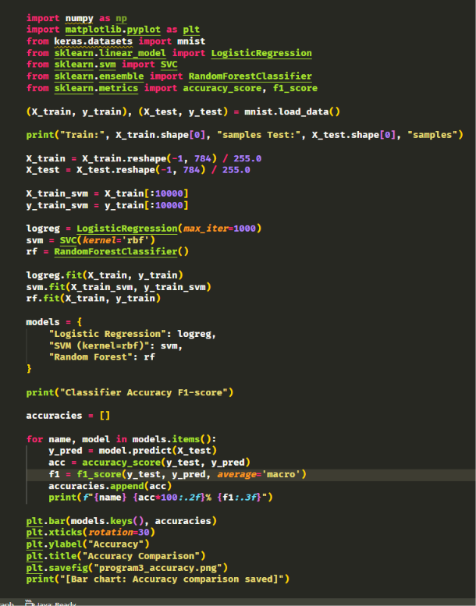

OUTPUT:
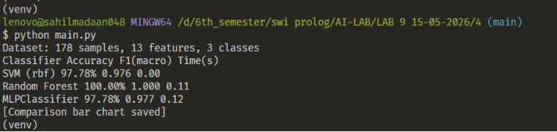

PLOT:
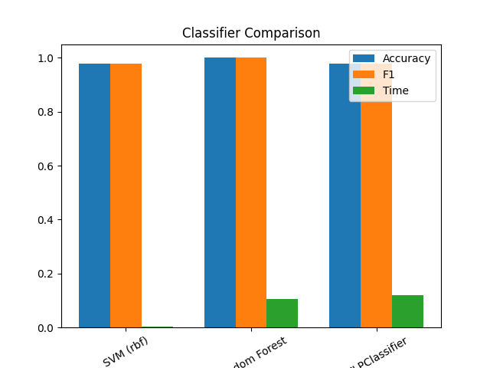

Lab 9
Program 4 — Multiclass Classification — SVM, Random Forest & Neural Networks
